Quercetin Protects Against Reserpine-Induced Fibromyalgia in Rats Through Modulation of Oxidative Stress and Inflammatory Responses
Abstract
Background: Widespread physical pain, exhaustion, psychological disorders, and sleep problems are the hallmarks of fibromyalgia (FM), a chronic illness. Quercetin (Qrct) possesses anti-inflammatory and anti-oxidant qualities.
Objective: This study used a reserpine-induced FM rat model to assess Qrct's efficacy in reducing pain, anxiety, and depression.
Method: Three groups of thirty male rats were used: control, RES, and RES + Qrct. Tail flick latency and rotarod tests were used to measure pain, whereas the open field, elevated plus maze, and forced swim tests were used for behavioral evaluations. Neurotransmitters, antioxidants, pro-inflammatory cytokines, and the expression of the NF-kB and CGRP genes were all examined in brain homogenates. The cerebral cortex's histopathological analysis evaluated indicators of apoptosis and inflammation.
Results: The treatment of Qrct enhanced behavior and decreased discomfort, according to the results. This was associated with elevated SOD and IL-10 and decreased MDA and TNF-α levels. Furthermore, Qrct reduced the expression of the NF-kB gene and CGRP.
Conclusion: Qrct's antioxidant, anti-inflammatory, neuroprotective, and anti-apoptotic qualities reduce FM symptoms, suggesting that it may be used as a treatment for FM.
KeyWords: Quercetin, Reserpine, CGRP, NF-kB, Caspase-3
Introduction
Fibromyalgia has a very complicated and diverse etiopathogenesis. One important modulator in the pathophysiology of fibromyalgia is the CNS. Clinically, the main causes of fibromyalgia and related comorbidities include aberrant levels of serotonin, dopamine, inflammatory cytokines, and the antioxidant system. (Singh et al., 2021).
Serotonin and dopamine are also crucial for regulating nociception. Increased oxidative and inflammatory stress have also been clinically linked to fibromyalgia. Because of its high lipid content, the CNS is more vulnerable to lipid peroxidation. Studies have shown that oxidative damage modifies the pain response. (Singh et al., 2021)
Affected people experience central sensitization and hyperalgesia as a result of diminished serotonergic activity. Furthermore, there is mounting evidence that the start and course of FM are influenced by oxidative stress & neuroinflammation (Alhawiti,et al., 2026).
A popular and commonly used animal model of fbromyalgia is reserpine-induced fbromyalgia, which mimics the clinical biochemical alterations and symptoms of fbromyalgia, including monoamine depletion, decreased pain threshold, cognitive impairment, and depression-like behavior. Monoamine reserves have been shown to be depleted by repeated reserpine administration. Monoamine depletion results in tactile allodynia, depression, and persistent muscle pain. Additionally, reserpine raises pro-inflammatory cytokine levels and lipid peroxidation. (Singh et al., 2021).
FM is a complicated with headaches, depression, exhaustion, sleep problems, and cognitive impairment. The lack of clear diagnostic biomarkers make the disorder difficult to diagnose. The precise etiology and pathophysiology mechanisms behind FM are still poorly known after decades of research, which has made it difficult to design effective therapeutic strategies ((Alhawiti,et al., 2026) et al., 2026).
There are several contributing elements to the complicated situation. Its development and persistence are mostly attributed to two mechanisms: central sensitization and persistent oxidative stress. The precise cause of FM is still unknown, despite tremendous progress in our understanding of its pathophysiology. Decreased levels of serotonin and norepinephrine and increased levels of excitatory neurotransmitters including glutamate and substance P are the main cause of FM. Dopamine dysregulation and compromised endogenous brain opioid activity are two more anomalies. (Khodir et al., 2025).
These elements appear to support the fundamental pathophysiology of FM. Additionally, a possible peripheral pathogenic element in the etiopathogenesis of FM could be inflammation. (Cordero et al., 2011)
When sensory neurons release inflammatory neuropeptides to cause inflammation, this is known as neurogenic inflammation. Additional neuropeptides and neurotrophins are released when CGRP is stimulated. These substances further activate nerve fibers by drawing inflammatory cells, which exacerbates the inflammatory response. The rise in excitatory neurotransmitters like CGRP or the fall in inhibitory neurotransmitters like serotonin and norepinephrine are caused by central sensitization, which is believed to be involved in the pathophysiology of FM. (Khodir et al., 2025).
NF-kB is a pleiotropic regulator of immune response, inflammation, pain, and cell survival and death pathways. Its up-regulation is linked to the pathophysiology of pain. Inflammatory conditions like FM have been linked to glutamate excitotoxicity, which is mediated by NF-kB activation. An increase in inflammatory mediators, such as cytokines, has been linked to FM. (Kaur et al., 2019).
As of right now, FM has no known cure. Pharmacological treatments such as antidepressants, anticonvulsants, sleep aids, and analgesics like opioids are frequently used to treat symptoms. However, these medications' limited effectiveness and serious side effects, including as hepatotoxicity and dependence, often restrict their long-term usage. As a result, there has been a growing movement to investigate safer and more potent alternative treatments, especially those made from natural sources. (Alhawiti et al., 2026).
Quercetin (Qrct) is one of the several flavonoid components present in fruits and vegetables. There is growing evidence that Qrct possesses antinociceptive qualities in animal models of chronic pain. In the past, FM sufferers' fatigue, discomfort, and muscle dysfunction were all lessened by Qrct. This might lessen the two main FM symptoms without requiring a variety of medications with various side effects (Hassan et al., 2025)
Berries, red wine, and onions are just a few of the plants and plant-based foods that contain Qrct. It possesses anti-inflammatory qualities in addition to antioxidant and free radical scavenger effects by regulating transcription factors and enzymes in the inflammatory signaling cascade. (Wu et al., 2019).
In a RES-induced fibromyalgia model in adult male albino rats, this study sought to examine the possible function of Qrct in reducing pain, anxiety, and depression as well as to uncover the underlying mechanisms by which it achieves these benefits.
Materials and Methods

With IRB No. 8/2026PHYS2-2, this study was carried out in accordance with the rules established by the Ethics Committee of the Menoufia University Faculty of Medicine. Thirty male rats weighing between 175 and 200 grams were employed. Regular rat food and tap water are also freely available to them.

Experimental groups
Control Group: For three days in a row, the rats in this group received a daily s.c. injection of 0.5% acetic acid at a dose of 1 ml/kg of body weight. Additionally, for twenty-one days in a row, 1 mL DW was administered intragastrically.
Reserpine-Induced Fibromyalgia Group (RES Group): This group was given a daily to induce a fibromyalgia (FM) model s.c. injecting reserpine (Sigma-Aldrich Chemical Co., St. Louis, MO, USA) for three days in a row at a dose of 1 mg/kg, dissolved in 0.5% acetic acid, using the procedure outlined by Nagakura et al. 2022
Rats were concurrently given Qrct vehicle intragastrically for 21 days in a row beginning on the first day of the study period. Reserpine-induced FM was successfully induced using the OFT, EPM Test, and FST.
Reserpine-Induced Fibromyalgia Treated with Quercetin (RES + Qrct Group): Rats in this group received the same treatment as those in the RES group. Rats were concurrently given Qrct supplementation, which was purchased from Sigma Aldrich (St. Louis, MO) and dissolved in DW, at a dose of 25 mg/kg beginning on the first day of the research period and continuing for 21 days. For twenty-one days, the Qrct was given intragastrically. (Hassan et al., 2025).
On day 19 of the trial, rats underwent OFT, EPM, and FST at intervals of two hours. On the twentieth day of the trial, the Tail Flick Latency Test was conducted. Rats underwent a rotarod performance test on the twenty-first day of the study. Following the completion of the behavioral tests, the rats were sacrificed. After that, their brains were removed, dried, and weighed after being cleaned with saline. Each brain was split in half, with the first half being used for immunohistochemical and histological investigations and the second half being frozen in liquid nitrogen and kept at -80 °C for biochemical analysis.
Behavioral assessment
OFT
The rat's locomotor activity was evaluated using OFT. The Open Field Test was conducted in a hardwood arena that measured 100 × 100 × 60 cm and was divided into 25 squares, each measuring 20 cm. After being positioned in the middle of the arena, each rat was given fifteen minutes to freely explore. Each rat's ambulation frequency and delay to depart the starting point were measured in seconds. (Khodir et al., 2025)
EPM Test
Rats' anxiety-like behavior was evaluated using EPM. Rats' anxiety-like behavior was evaluated using the Elevated Plus Maze, a plus-shaped device. After being positioned in the middle of the maze, each rat was given ten minutes to explore. The rats' movements were captured by an overhead camera, and the amount of time they spent in the maze's open arms was calculated. The amount of time spent in the open arms, measured in seconds using a stopwatch, was inversely correlated with anxiety-like behavior. (Khodir et al., 2025)
FST
The Forced Swim Test was administered to all groups with minor adjustments. A glass tank of 30 cm in diameter by 40 cm in depth was filled with 25 cm of water at 25 °C for each rat. The test examined the latency to the first instance of immobility as well as the duration of immobility, which is defined as the least amount of movement necessary to keep the rat's head above water, in seconds over a 5-minute period. (Khodir et al., 2025)
Pain assessment
Tail Flick latency test
One test used to determine a rat's pain threshold is the tail flick latency test. A tail flick device (Harvard Apparatus, USA) was used to measure the thermal nociceptive response in the Tail Flick Latency Test. The rats were handled carefully, and a spot three centimeters from the tip of their tails was exposed to radiant heat. The rat's tail-flick latency, or latency to flick its tail, was measured in seconds. The heat stimulus was stopped after ten seconds (cutoff delay) in order to prevent tissue injury.) (Khodir et al., 2025)
Rotarod performance test
The Rotarod. Balance and motor coordination were assessed using a performance test. An accelerating rotarod was used to test rats; the speed was increased from 5 to 16 rpm over the course of one minute, and it was then maintained at that speed. A maximum cutoff time of three minutes was used to record the amount of time until the first fall. The time to fall in seconds is used to convey the facts. (Khodir et al., 2025)
Biochemical assessment
MDA and SOD levels in the brain were measured using calorimetric kits from the Biodiagnostic Company (Dokki, Giza, Egypt). Rat ELISA kits were used to measure the levels of dopamine, serotonin, TNF-α, and IL-10 in the brain: Dopamine (201-11-0220, Sunred CO., Shanghai, China), serotonin (201-12-1712, Sunred, Shanghai, China), TNF-α (Assaypro LLC, Saint Charles, Missouri, USA), and IL-10 (ab214566, Abcam, Cambridge, UK), as directed by the manufacturer.
qRT-PCR
Rat QIAzol reagent (Cat. No. 79306, Qiagen, Germany) was used to isolate total RNA, which was then quantified and purified using a NanoDropTM 2000/2000c Spectrophotometer. A Geneamp 2720 Thermal Cycler ABI (Applied Biosystems, USA) was then used to convert 1 μg of the isolated RNA to cDNA using ABT 2× RT Mix (Cat. No. AMP-11, Applied Biotechnology, Egypt). The 95°C (denaturation stage), followed by 40 cycles of repeated 10 seconds at 95°C and 30 seconds at 60°C. Glyceraldehyde-3-phosphate dehydrogenase (GAPDH), CGRP, and NF-kB NCBI-Primer BLAST was used for cross-verification after primer sequences were created using Primer3 Plus software. Following All target and housekeeping genes underwent triplicate RT-PCR testing. Using GAPDH as the endogenous housekeeping control gene, the relative mRNA expression of the target genes was determined using the comparative 2^{−ΔΔCt} technique (Livak & Schmittgen, 2001)..
Table (1): Primers for qRT-PCR
Target | Primer sequences | The size of the product | RefSeq
Rat GAPDH | 5′-TGGGAAGCTGGTCATCAAC-3′(F)  5′-GCATCACCCCATTTGATGTT-3′(R) | 78 bp | NM_017008.4
Rat NF-kB | 5′-GCTTTGCAAACCTGGGAATA-3′(F)  5′-CAAGGTCAGAATGCACCAGA-3′(R) | 123 bp | NM_001415012.1
Rat CGRP | 5′-TCTAGTGTCACTGCCCAGAAGAGA-3′(F)  5′-GGCACAAAGTTGTCCTTCACCACA-3′(R) | 110 bp | NM_001033956.1

Histopathological analysis
following formalin fixation. The sections were stained using standard H&E stain.
IHC staining of the brain for NF-kB and caspase-3 Immunohistochemical (IHC): Brain tissue was stained for Caspase-3 & NF-kB immunostained sections using NF-kB (monoclonal; dilution of 1:200, Abcam-Cambridge-UK) against Caspase-3 (Ab-7, Mouse Mab. MS).
Statistical analysis
All data were expressed using the mean ± SD. The data was analyzed using SPSS software version 16 (SPSS Inc., Chicago, IL, USA). ANOVA and a post hoc Tukey test were used to assess the significance between the groups. Statistical significance was defined as a P value of less than 0.05..
Results:
Latency time in OFT, brain MDA and brain TNF-α, immobility time in FST, brain MDA. brain TNF-α and brain CGRP & NF-kB gene expression . Latency were all dramatically higher in the RES group than in the control group with lower Ambulation frequency in OFT, Time in open arms of EPM, Immobility latency in FST, Withdrawal latency in tail flick, Time to fall in Rotarod test, brain SOD, brain IL-10. time in OFT, brain MDA and brain TNF-α, immobility time in FST, brain MDA, brain TNF-α and brain CGRP & NF-kB gene expression were all dramatically lower in the RES+Qrct group than in the RES group with higher Ambulation frequency in OFT, Time in open arms of EPM, Immobility latency in FST, Withdrawal latency in tail flick, Time to fall in Rotarod test, brain SOD, brain IL-10 . Table 2
Table (2): Latency time in OFT, Ambulation frequency in OFT, Time in open arms of EPM, Immobility time in FST, Immobility latency in FST, Withdrawal latency in tail flick, Dopamine, Serotonin , MDA, SOD, TNF-α, IL-10, and brain NF-kB & CGRP gene expression in the research groups (total 30 rats, 10 for each group)
RES+Qrct group | RES group | Control group
24.8±1.2 *# | 35.9±2.3* | 19.8±2.11 | Latency time in OFT (Sec)
37.8±3.7 *# | 16.8±1.4* | 51.8±2.1 | Ambulation frequency in OFT
27.8±2.3 *# | 11.8±3.1* | 41.8±5.9 | Time in open arms of EPM (Sec)
63.2±1.2 *# | 98.2±1.4 | 34.5±2.1 | Immobility time in FST (Sec)
43.5±1.17 *# | 27.5±3.1 * | 62.5±1.4 | Immobility latency in FST
5.2±0.4 *# | 3.1±0.11* | 8.3±0.3 | Withdrawal latency in tail flick
41.2±3.4 *# | 18.9±2.1* | 65.2±0.12 | Time to fall in Rotarod test (Sec)
1.47±0.18 *# | 0.71±0.1* | 3.11±0.18 | Dopamine (ng/ml)
95.2±2.1*# | 63.5±3.1* | 120.5±4.12 | Serotonin (ng/ml)
8.6±0.14*# | 11.99±0.15* | 6.88±0.3 | Brain MDA (nmol/ gm. Tissue)
3.45±0.33*# | 2.11±0.12* | 4.55±0.45 | Brain SOD (U/gm. Tissue )
38.9±1.6*# | 53±2.3* | 24.5±2.1 | Brain TNF-α (ng/L)
62.5±1.9*# | 41.3±5.8* | 80.5±2.1 | Brain IL-10 (pg/ml)
2.35±0.03*# | 3.25±0.05* | 1 | Gastric NF-kB gene expression
1.93±0.04*# | 2.6±0.02* | 1 | Gastric CGRP gene expression
* Significant compared with control, # Significant compared with RES.
H & E Results
The control group's cerebral cortex showed normal architecture with six neatly arranged cortical layers covered by the pia mater, according to histological analysis. Granular and glial cells had normal shape, whereas pyramidal neurons had vesicular nuclei, basophilic cytoplasm, and large apical dendrites. A uniform eosinophilic background was the appearance of the neuropil (Fig. 1A,B). Significant neuronal degeneration, including increased apoptotic cells, pyknotic nuclei, reduced pyramidal cells, cytoplasmic vacuolization, perineuronal halos, and widespread neuropil vacuolation, was seen in the RES group. Cellular infiltrates and dilated blood vessels were further findings (Fig. 1C). Cortical tissues in the RES+Qrct group recovered significantly, exhibiting improved morphology, decreased apoptosis, and less neuropil vacuolization (Fig. 1D).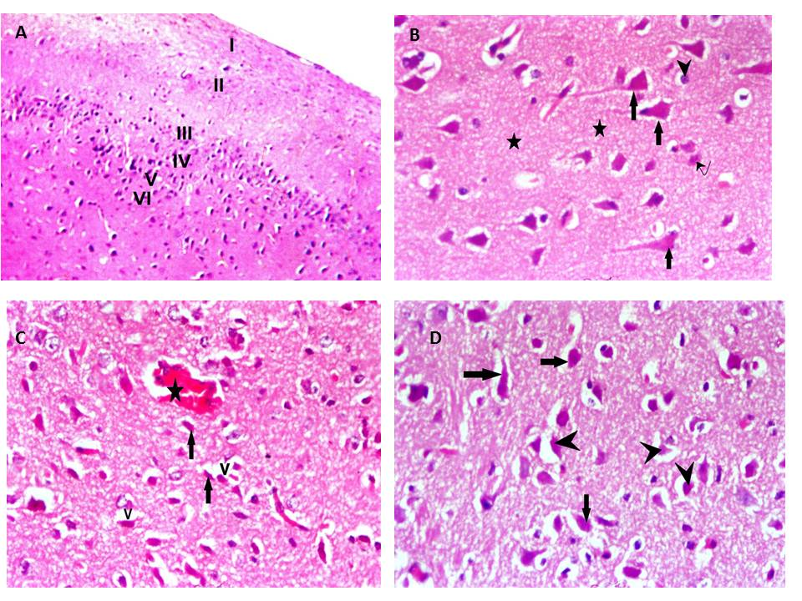
Fig. 1: The pia mater (arrow) and the six cortical layers—are seen in this photomicrograph of the frontal motor cortex of a control rat (A) (H&E, ×100). B) The control group's normal pyramidal cells (arrows) with vesicular nuclei and basophilic cytoplasm, granular cells (curved arrows), glial cells (arrowheads), and eosinophilic neuropils (asterisks) (H&E, ×400). C) RES Group displaying red neurons (short arrow), congested dilated blood arteries (asterisks), neuropil vacuolization (V), and darkly stained pyramidal cells with pyknotic nuclei and perineuronal halos (arrows) (H&E, ×400). D) The RES+Qrct Group is primarily composed of granular cells (curved arrow) and normal pyramidal cells (arrow), with a few shrunken pyramidal cells encircled by halos (arrowhead) (H&E, ×400).
Immunohistochemical results
The RES's Caspase-3 intensity was much higher than the control (85.2±1.2 vs. 11.25±2.1). Compared to the RES, the Caspase-3 intensity in the RES+Qrct was significantly lower (34.5±1.3 vs. 85.2±1.2). (Fig.2A-D).
NF-κB intensity in RES was dramatically higher than control (82.5±2.1 vs 9.3±1.1). NF-κB intensity in RES+Qrct was dramatically lower than RES (34.7±1.2 vs 82.5±2.1). (Fig.2E-H).

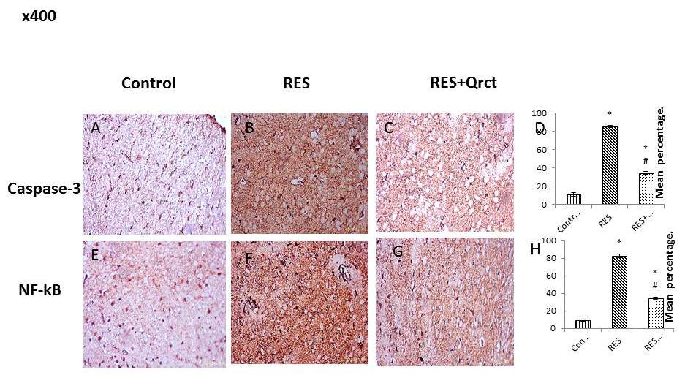
Fig (2): Caspase-3 (A-D) and NF-kB (E-H) immunoreaction are dramatically elevated in the RES and dramatically downregulated in the RES+Qrct, according to representative micrographs of the various experimental groups.
Discussion
FM is a complex condition that affects the entire body and includes persistent pain, exhaustion, and depression. Nonsteroidal anti-inflammatory medications and opioids are frequently ineffective against FM. Furthermore, the most often used medications with a number of adverse effects are antidepressants. (Lai et al., 2023).
Extreme fatigue, psychological issues (such as worry and/or depression), and sleep disturbances are among the other symptoms associated with FM. Comorbid symptoms vary by demographics; up to 90% of FM patients experience pain and sleep issues, 40% experience depression or anxiety, and up to 100% experience exhaustion. (Arnold et al., 2019).
By depleting neurotransmitters like serotonin, reserpine is known to induce depression and exhaustion, which in turn causes food intake to decrease and weight loss. (Alhawiti et al., 2026).
RES group withdrawal latency in the tail flick and time to fall in the Rotarod test in comparison to the control group which are consistent with earlier research (Alhawiti et al., 2026). The characteristics of fibromyalgia-like symptoms, such as decreased motor activity, muscle weakness, and increased pain sensitivity, are caused by reserpine's depletion of dopamine and serotonin. (Yao et al., 2020)
Behavioral evaluations in the current investigation showed that rats given reserpine showed extended OFT latency delay and reduced frequency of ambulation In the open-field test, consistent with earlier results (Ferrarini et al., 2022). Similarly, the rotarod test's noticeably reduced delay supports the idea that reserpine-induced neurotransmitter depletion contributes to motor dysfunction. (Alhawiti et al., 2026).
According to Singh et al. (2021), FM is linked to lower levels of biogenic amines, especially serotonin, which activates endogenous analgesic processes and is essential for descending pain-modulating pathways in the brain and spinal cord. According to FM Singh et al. (2021), low serotonin levels are therefore associated with heightened pain perception. Reserpine administration dramatically decreased serotonin and dopamine levels in the current investigation as compared to controls, which resulted in the depletion of brain biogenic amines (Sousa et al., 2018).
Quercetin is one of the several flavonoid components present in fruits and vegetables. There is growing proof that quercetin possesses antinociceptive qualities in animal models of chronic pain. (Liu et al., 2022).
We therefore hypothesized that quercetin could be helpful to lessen pain and depression in FM because of its ability to reduce discomfort. This might lessen the two main FM symptoms without requiring a variety of medications with various side effects. (Hassan et al., 2025).
In the current research, Qrct dramatically ameliorated the OFT, rotarod and Tail flick latency test performance compared to RES group. This align with prior study which revealed that the motor activity of the hindlimb muscles of rats was enhanced by Qrct. Additionally, it improved mechanical PPT concurrent with decreased serum substance P level. Qrct inhibits the enzyme that produces PGE2 and the COX-2-cascade, as well as regulates neuronal excitability, involving nociceptive sensory transmission via voltage-gated potassium, sodium, and calcium channels. Consequently, Qrct may have potential as a treatment for nociceptive and/or pathological pain (Sashide et al., 2024, Toyota et al., 2023). Additionally, it has been observed that Qrct inhibits the synthesis of neuropeptides including substance P and nerve growth factor (Toyota et al., 2023).
This study revealed that the RES group spent less time on the EPM test than the controls, indicating anxiety and depression in this model, whereas the immobility time in the FST was considerably higher in the RES group than in the controls. The same findings were noted by Yao et al., suggesting that depression and allodynia and hyperalgesia are common comorbidities in FM. (Yao et al., 2020).
According to Nagakura et al. (2022), repeated reserpine doses cause the nervous system's biogenic amines to be depleted, which can lead to the development of sensory hypersensitivity and behaviors that resemble depression and anxiety.
However, Qrct significantly reduced the anxiety and despair brought on by RES, which is consistent with Qrct's prior antidepressant impact. (Guan et al., 2021, Ma et al., 2021)
A number of neurological conditions, including anxiety and depression, have been linked to oxidative stress, which is defined by an imbalance between the generation of ROS and antioxidant defenses. (Cecerska-Heryć et al., 2021)
It has been demonstrated that FM patients have lower plasma antioxidant levels and higher levels of lipid peroxidation. In comparison to the rats in the control group, the RES rats showed considerably greater levels of MDA, and decreased levels of SOD. By autoxidizing dopamine and stimulating oxidative catabolism through monoamine oxidase, reserpine, a recognized monoamine depleter, can cause oxidative stress (Assavarittirong et al., 2022). Reduced levels of SOD are a sign that these activities can cause dopamine neurons to produce hydrogen peroxide and quinones, which can alter the redox status of their neuronal terminals (Khodir et al., 2025).
However, Qrct therapy reduced MDA and raised SOD activity in comparison to the RES group, indicating their antioxidant function and corroborating earlier research (de Mattos et al., 2020). Qrct's antioxidant function is associated with its chemical composition because the hydroxyl groups attached to the aromatic rings have the capacity to neutralize reactive molecules such as ROS. In addition to its capacity to upregulate the Nrf2/HO-1 signaling pathway (Li et al., 2019), this chemical can protect tissues from lipid peroxidation, which is mostly caused by the superoxide anion and hydroxyl radical, by chelating metals and/or absorbing free radicals (de Mattos et al., 2020).
RES significantly raised inflammatory cytokines in comparison to control, which is consistent with other research. (Khodir et al., 2025). NF-kB up-regulation is linked to the pathophysiology of pain. RES increases the expression of pro-inflammatory mediators resulting in a decrease in microglia and astrocyte activation. It has been discovered that glutamate excitotoxicity is linked to caspase activation and NF-kB-regulated proapototic gene activation. NF-kB activation has been shown to mediate glutamate excitotoxicity in inflammatory illnesses like FM.. (Kaur et al., 2019)
Our findings showed that the RES group had higher brain NF-kB immunoreaction than the control group. Reserpine therapy has also been linked to an increase in inflammatory cytokines. According to these results, reserpine causes an inflammatory insult, as evidenced by an increase in cytokines that start the NF-kB activation cascade (Kaur et al., 2019).
However, in line with previous studies, Qrct considerably decreased the inflammatory state brought on by RES (Wu et al., 2019). By lowering the synthesis of inflammatory factors, Qrct may have an anti-inflammatory impact. Our results showed that via blocking the NF-κB pathway, Qrct had a protective impact (Wu et al., 2019). Wang et al. reported that the Qrct demonstrated anti-inflammatory and anti-oxidative characteristics, potentially through blocking TLR4-mediated NF-κB, caspase-1, TNF-α, IL-1β, and IL-6 (Wang et al., 2017).
.
CGRP, substance P, neurokinin-1 receptors, and NMDA-glutamate receptors have all been linked to the neurotransmission of pain in earlier studies. CGRP showed a substantial negative connection with DA, serotonin, and NE, according to earlier research. Injecting CGRP into the hippocampus dramatically lowers hippocampal DA, which causes anxiety-like behavior. (Khodir et al., 2025). Additionally, a study has shown that CGRP can increase IL-6 production in response to TNF-α or IL-1β, underscoring its function in inflammatory processes. ( Kim et al., 2021)
To the best of our knowledge, this work is the first to look into how Qrct affects CGRP expression in FM caused by RES. Significantly higher levels of dopamine and serotonin were seen in the RES + Qrct group, which may account for the improvements in pain management and behavioral indicators of anxiety and sadness.
Apoptosis is triggered by FM. The results of this investigation support those of a prior study that found that the RES group had higher levels of caspase-3 cerebral immunreaction than the control group (Khodir et al., 2025). Qrct treatment successfully decreased caspase-3 activity in this investigation. These results are in line with earlier studies emphasizing Qrct's preventive benefits (Yang et al., 2014).
Conclusion: These results imply that Qrct's antioxidant, anti-inflammatory, neuroprotective, and anti-apoptotic qualities reduce FM symptoms, suggesting that it may be used as a treatment for FM.
References
- Alhawiti, O. H., Batawi, A. H., Al-Thepyani, M. A., Tash, R., Almuhammadi, A., Alsabban, A. H., Azhari, S. A., & Alghamdi, B. S. (2026). Moringa oleifera L. leaf extract attenuates neuroinflammation and behavioral alterations in a fibromyalgia mice model: Modulation of serotonin and cytokine pathways. IBRO Neuroscience Reports, 20, 317–331. https://doi.org/10.1016/j.ibneur.2026.02.010
- Arnold, L. M. et al. AAPT diagnostic criteria for fibromyalgia. J. Pain. 20, 611–628. https://doi.org/10.1016/j.jpain.2018.10.008 (2019).
- Assavarittirong, C., Samborski, W. & Grygiel-Górniak, B. Oxidative stress in fibromyalgia: from pathology to treatment. Oxid. Med. Cell. Longev. 2022(1582432). https://doi.org/10.1155/2022/1582432(2022).
- Cecerska-Heryć, E. et al. Importance of oxidative stress in the pathogenesis, diagnosis, and monitoring of patients with neuropsychiatric disorders, a review. Neurochem. Int. 153, 105269. https://doi.org/10.1016/j.neuint.2021.105269(2022).
- Cordero, M. D. et al. Clinical symptoms in fibromyalgia are better associated to lipid peroxidation levels in blood mononuclear cells rather than in plasma. PLoS One. 6, e26915. https://doi.org/10.1371/journal.pone.0026915(2011).
- de Mattos, B. D. S., Soares, M. S. P., Spohr, L., Pedra, N. S., Teixeira, F. C., de Souza, A. A., ... & Spanevello, R. M. (2020). Quercetin prevents alterations of behavioral parameters, delta‐aminolevulinic dehydratase activity, and oxidative damage in brain of rats in a prenatal model of autism. International Journal of Developmental Neuroscience, 80(4), 287-302
- Ferrarini, E.G., et al., 2022. Broad-spectrum cannabis oil ameliorates reserpine-induced fibromyalgia model in mice. Biomed. Pharm. 154, 113552.
- Guan Y, Wang J, Wu X, Song L, Wang Y, Gong M, Li B. Quercetin reverses chronic unpredictable mild stress-induced depression-like behavior in vivo by involving nuclear factor-E2-related factor 2. Brain Res. 2021 Dec 1;1772:147661. doi: 10.1016/j.brainres.2021.147661. Epub 2021 Sep 13. PMID: 34529966.
- Hassan, F. E., Eid, D. M., & Al Dreny, B. A. (2025). Glucagon-like peptide-1 agonist and quercetin improve skeletal muscle performance and pain threshold in male rats with fibromyalgia via activating the Nrf2/HO1/NQO1 pathway. Bulletin of Egyptian Society for Physiological Sciences, 45(3), 282–295. https://doi.org/10.21608/BESPS.2025.351962.1197
- Kaur, A., Singh, L., Singh, N., Bhatti, M. S., & Bhatti, R. (2019). Ameliorative effect of imperatorin in chemically induced fibromyalgia: Role of NMDA/NFκB mediated downstream signaling. Biochemical Pharmacology, 166, 56–69. https://doi.org/10.1016/j.bcp.2019.05.012
- K.J. Livak, T.D. Schmittgen, Analysis of relative gene expression data using real time quantitative PCR and the 2(-delta delta C(T)) method, Methods 25 (2001) 402–408, https://doi.org/10.1006/METH.2001.1262.
- Khodir, S. A., Sweed, E. M., El-Haroun, H., Abd-Elhamid, T. H., El Derbaly, S. A., Mahmoud, A. R., & Motawea, S. M. (2025). Honokiol ameliorates reserpine-induced fibromyalgia through antioxidant, anti-inflammatory, neurotrophic, and anti-apoptotic mechanisms. Scientific Reports, 15, 25983. https://doi.org/10.1038/s41598-025-07209-w
- Kim, Y. J. & Granstein, R. D. Roles of calcitonin gene-related peptide in the skin, and other physiological and pathophysiological functions. Brain, Behavior, & Immunity - Health 18, 100361. https://doi.org/10.1016/j.bbih.2021.100361(2021).
- Lai, P. C., Yen, C. M., Lin, M. C., Chen, Y. H., Liao, H. Y., Huang, Y. W., & Lin, Y. W. (2023). Electroacupuncture attenuates fibromyalgia pain via Toll-like receptor 4 in the mouse brain. Life, 13(5), 1160. https://doi.org/10.3390/life13051160
- Li, Y., Tian, Q., Li, Z., Dang, M., Lin, Y., Hou, X., 2019. Activation of Nrf2 signaling by sitagliptin and quercetin combination against beta-amyloid induced Alzheimer's disease in rats. Drug Dev. Res. 80 (6), 837–845.
- Liu C, Liu DQ, Tian YK, Mei W, Tian XB, Xu AJ, et al. The Emerging Role of Quercetin in the Treatment of Chronic Pain. Curr Neuropharmacol. 2022 Nov;20(12):2346–53.
- Ma ZX, Zhang RY, Rui WJ, Wang ZQ, Feng X. Quercetin alleviates chronic unpredictable mild stress-induced depressive-like behaviors by promoting adult hippocampal neurogenesis via FoxG1/CREB/ BDNF signaling pathway. Behav Brain Res. 2021 May 21;406:113245. doi: 10.1016/j.bbr.2021.113245. Epub 2021 Mar 18. PMID: 33745981.
- Nagakura, Y. Therapeutic approaches to nociplastic pain based on findings in the Reserpine-Induced Fibromyalgia-Like animal model. J. Pharmacol. Exp. Ther. 381, 106–119. https://doi.org/10.1124/jpet.121.001051(2022).
- Sashide Y, Toyota R, Takeda M. Local Administration of the Phytochemical, Quercetin, Attenuates the Hyperexcitability of Rat Nociceptive Primary Sensory Neurons Following Inflammation Comparable to lidocaine. J Pain [Internet]. Liraglutide and Quercetin improve muscle performance and pain in FM 295 2024;25(3):755–65. Available from: https://www.sciencedirect.com/science/article/pii/S1526590023005758
- Singh, L., Kaur, A., Singh, A. P., & Bhatti, R. (2021). Daphnetin, a natural coumarin averts reserpine-induced fibromyalgia in mice: Modulation of MAO-A. Experimental Brain Research, 239(5), 1451–1463. https://doi.org/10.1007/s00221-021-06064-1
- Sousa, F.S.S., et al., 2018. α-(Phenylselanyl) acetophenone mitigates reserpine-induced pain–depression dyad: behavioral, biochemical and molecular docking evidences. Brain Res. Bull. 142, 129–137.
- Toyota R, Ito H, Sashide Y, Takeda M. Suppression of the Excitability of Rat Nociceptive Primary Sensory Neurons Following Local Administration of the Phytochemical, Quercetin. J pain. 2023 Mar;24(3):540–9.
- Wang C.P., Y.W. Shi, M. Tang, X.C. Zhang, Y. Gu, X.M. Liang, et al., Isoquercetin ameliorates cerebral impairment in focal ischemia through anti-oxidative, anti-inflammatory, and anti-apoptotic effects in primary culture of rat hippocampal neurons and hippocampal CA1 region of rats, Mol. Neurobiol. 54 (2017) 2126–2142.
- Wu, M., Liu, F., & Guo, Q. (2019). Quercetin attenuates hypoxia-ischemia induced brain injury in neonatal rats by inhibiting TLR4/NF-κB signaling pathway. International immunopharmacology, 74, 105704.
- Yang T, Kong B, Gu JW, Kuang YQ, Cheng L, Yang WT, Xia X, Shu HF. Anti-apoptotic and anti-oxidative roles of quercetin after traumatic brain injury. Cell Mol Neurobiol. 2014 Aug;34(6):797-804. doi: 10.1007/s10571-014-0070-9. Epub 2014 May 21. PMID: 24846663; PMCID: PMC11488927.
- Yao, X., et al., 2020. Attenuation of reserpine-induced fibromyalgia via ROS and serotonergic pathway modulation by fisetin, a plant flavonoid polyphenol. Exp. Ther. Med. 19, 1343–1355.

